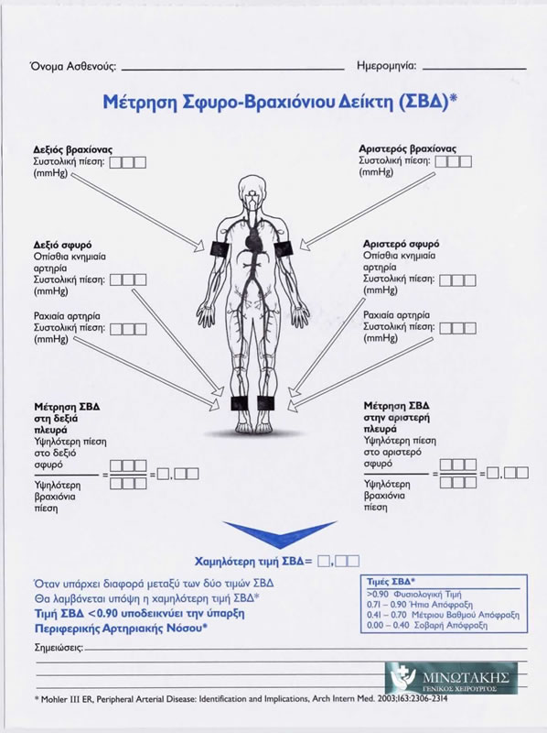

|  |  |
| --- | --- |
| https://btcenter.gr/userfiles/image/abi_de-jpeg.jpg | http://docplayer.gr/docs-images/46/10574504/images/page_3.jpg |